**Back-end technologies**

**Experiment 2**

**Student Name: Archana Srivastava UID: 22MCA20244**

**Branch: MCA Section/Group: 2A**

**Semester: 3rd Date of Performance: 21/08/23**

**Subject Name: Back-End Technology Subject Code:**

**Aim -:**

1. **Store a data obtained from 1.1 experiment save it in text file and show it**

**1.1 Employee.js**

constreadline = require('readline');

constfs = require('fs');

constrl = readline.createInterface({

input: process.stdin,

output: process.stdout

});

const employees = [];

functionaddEmployee() {

rl.question('Enter employee name: ', (name) => {

rl.question('Enter salary: ', (salary) => {

employees.push({ name, salary: parseFloat(salary) });

rl.question('Do you want to add another employee? (yes/no): ', (answer) => {

if (answer.toLowerCase() === 'yes') {

addEmployee();

} else {

saveToFile();

}

});

});

});

}

functionsaveToFile() {

let data = '';

employees.forEach(emp => {

data += `${emp.name},${emp.salary.toFixed(2)}\n`;

});

fs.writeFile('employees.txt', data, (err) => {

if (err) {

console.error('Error saving data:', err);

} else {

console.log('Data saved successfully.');

}

rl.close();

});

}

addEmployee();

**1.2 Read.js**

constfs = require('fs');

fs.readFile('employees.txt', 'utf8', (err, data) => {

if (err) {

console.error('Error reading data:', err);

} else {

const lines = data.split('\n');

console.log('Employee Data:');

lines.forEach(line => {

const [name, salary] = line.split(',');

console.log(`${name} - ${salary}`);

});

}

});

**Result/Output:**

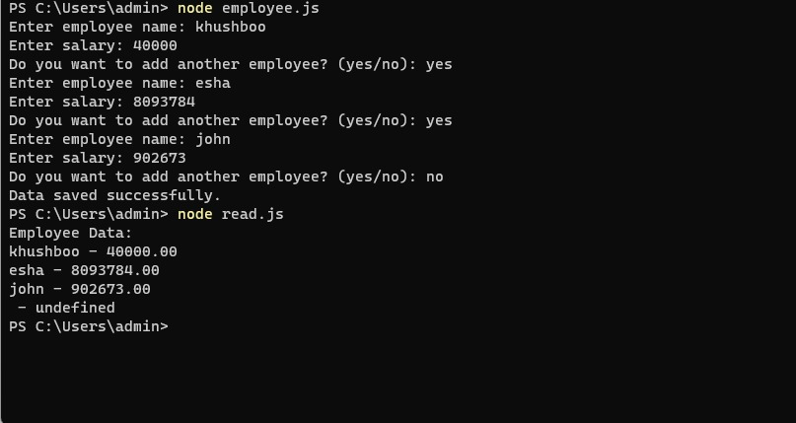

Archana

Archana

**Learning outcomes (What I have learnt):**

1. Understand application of node js
2. Learn about file system
3. Learn how to create text file in node js